PYTHON PROGRAMMING
CASE STUDIES
Algorithms • Flowcharts • Pseudocode • Source Code • Test Cases

A neatly organized collection of 10 Python case studies

Contents
- Program 1: Retail Billing with Multiple Discount Rules
- Program 2: Retail Billing with Multiple Discount Rules
- Program 3: Campus Event Financial Planning
- Program 4: Student Eligibility for Final Examination
- Program 5: Passenger Counting System
- Program 6: Electricity or Water Usage Savings Calculation
- Program 7: Student Academic Progression Eligibility
- Program 8: Classroom Seating Arrangement Using Nested Loops
- Program 9: Inventory and Stock Management System
- Program 10: Inventory and Stock Management System

PROGRAM 1

Retail Billing with Multiple Discount Rules

1. Problem Statement
Develop a Python program for a retail shop that accepts the number of products, their prices, and quantities purchased by a customer. Calculate the total cost, apply a 10% discount when the total amount is ₹2,000 or more, limit the maximum discount to ₹500, calculate 5% tax, and display the final bill.

2. Objectives

1. Accept the number of products from the customer.

2. Read product prices and quantities.

3. Calculate the cost of each product.

4. Calculate the total bill amount.

5. Apply a 10% discount for purchases of ₹2,000 or more.

6. Limit the maximum discount to ₹500.

7. Calculate 5% tax.

8. Display the final payable amount.

3. Assumptions

1. The customer purchases at least one product.

2. Product prices and quantities are positive.

3. A 10% discount applies when the total is ₹2,000 or more.

4. The maximum discount is limited to ₹500.

5. A 5% tax is applied to the original total amount.

6. All amounts are calculated in Indian rupees.

4. Algorithm

1. Start.

2. Input the number of products.

3. Initialize total to zero.

4. Repeat for each product:
o Input product price.
o Input product quantity.
o Calculate price × quantity.
o Add the cost to total.

5. If total is greater than or equal to ₹2,000, calculate a 10% discount; otherwise, set discount to zero.

6. Limit the discount to ₹500.

7. Calculate tax at 5% of the total.

8. Calculate final bill by subtracting discount and adding tax.

9. Display total, discount, tax, and final bill.

10. Stop.

5. Flowchart
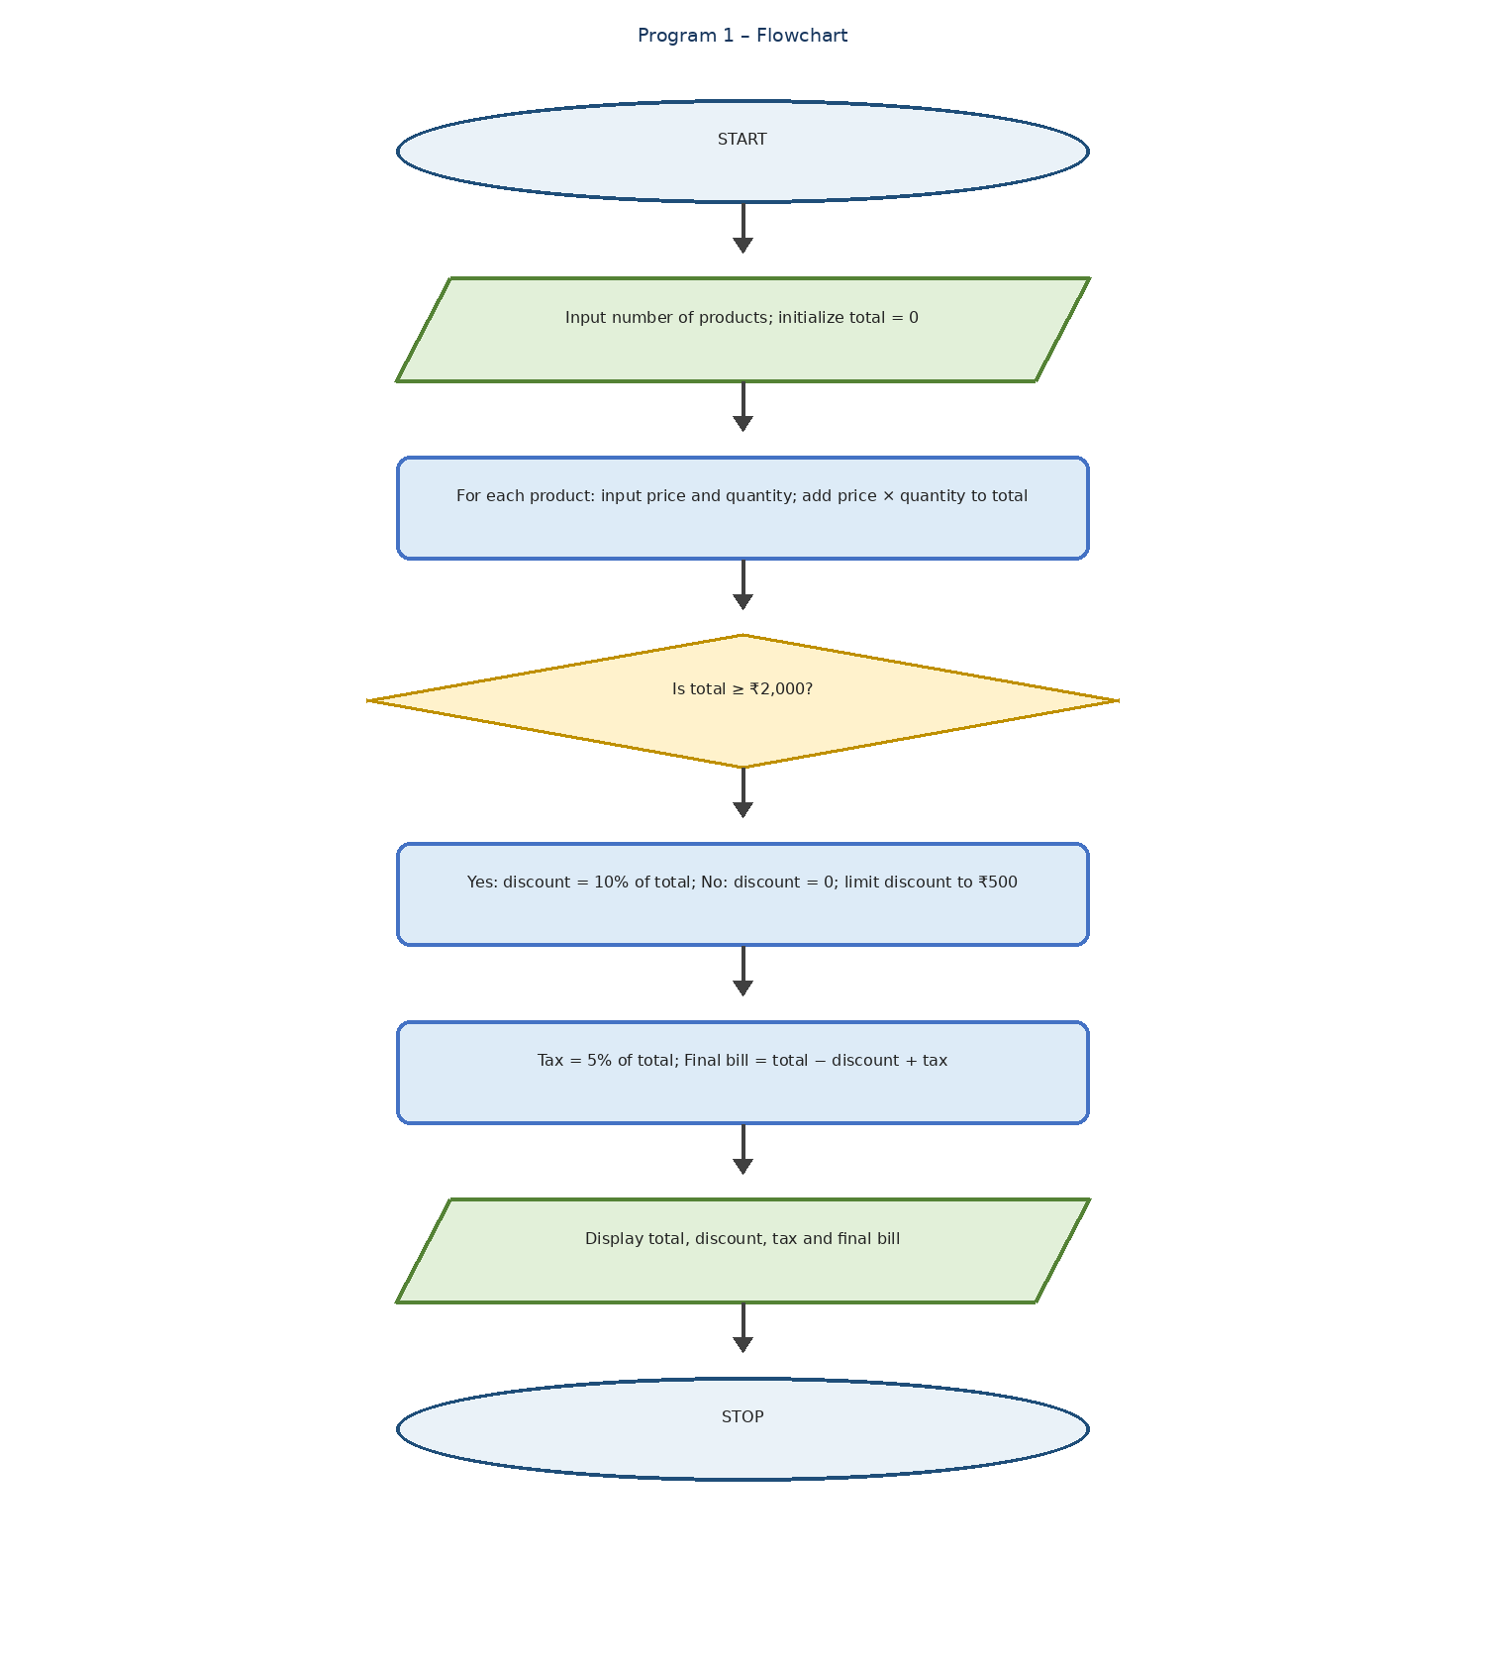
Algorithm (3) – Decision การสร้างทางเลือกให้โปรแกรม – TAmemo.com

6. Pseudocode
START
INPUT n
total = 0
FOR i = 1 TO n
INPUT price
INPUT quantity
total = total + price * quantity
END FOR
IF total >= 2000
discount = total * 0.10
ELSE
discount = 0
END IF
discount = MIN(discount, 500)
tax = total * 0.05
bill = total - discount + tax
DISPLAY total
DISPLAY discount
DISPLAY tax
DISPLAY bill
STOP

7. Python Source Code
n = int(input("Enter number of products: "))
total = 0
for i in range(n):
price = float(input("Enter price: "))
qty = int(input("Enter quantity: "))
total += price * qty
discount = total * 0.10 if total >= 2000 else 0
discount = min(discount, 500)
tax = total * 0.05
bill = total - discount + tax
print("Total:", total)
print("Discount:", discount)
print("Tax:", tax)
print("Final Bill:", bill)

8. Test Cases
Test Case 1: Total below ₹2,000
Input Value
Number of products 1
Price 500
Quantity 2
Total 1000
Expected result:
Total: 1000.0
Discount: 0
Tax: 50.0
Final Bill: 1050.0
Test Case 2: Total above ₹2,000
Input Value
Number of products 2
Price 1 1200
Quantity 1 1
Price 2 1000
Quantity 2 1
Total 2200
Expected result:
Total: 2200.0
Discount: 220.0
Tax: 110.0
Final Bill: 2090.0
Test Case 3: Maximum discount limit
Input Value
Number of products 1
Price 7000
Quantity 1
Total 7000
Expected result:
Total: 7000.0
Discount: 500
Tax: 350.0
Final Bill: 6850.0

9. Output

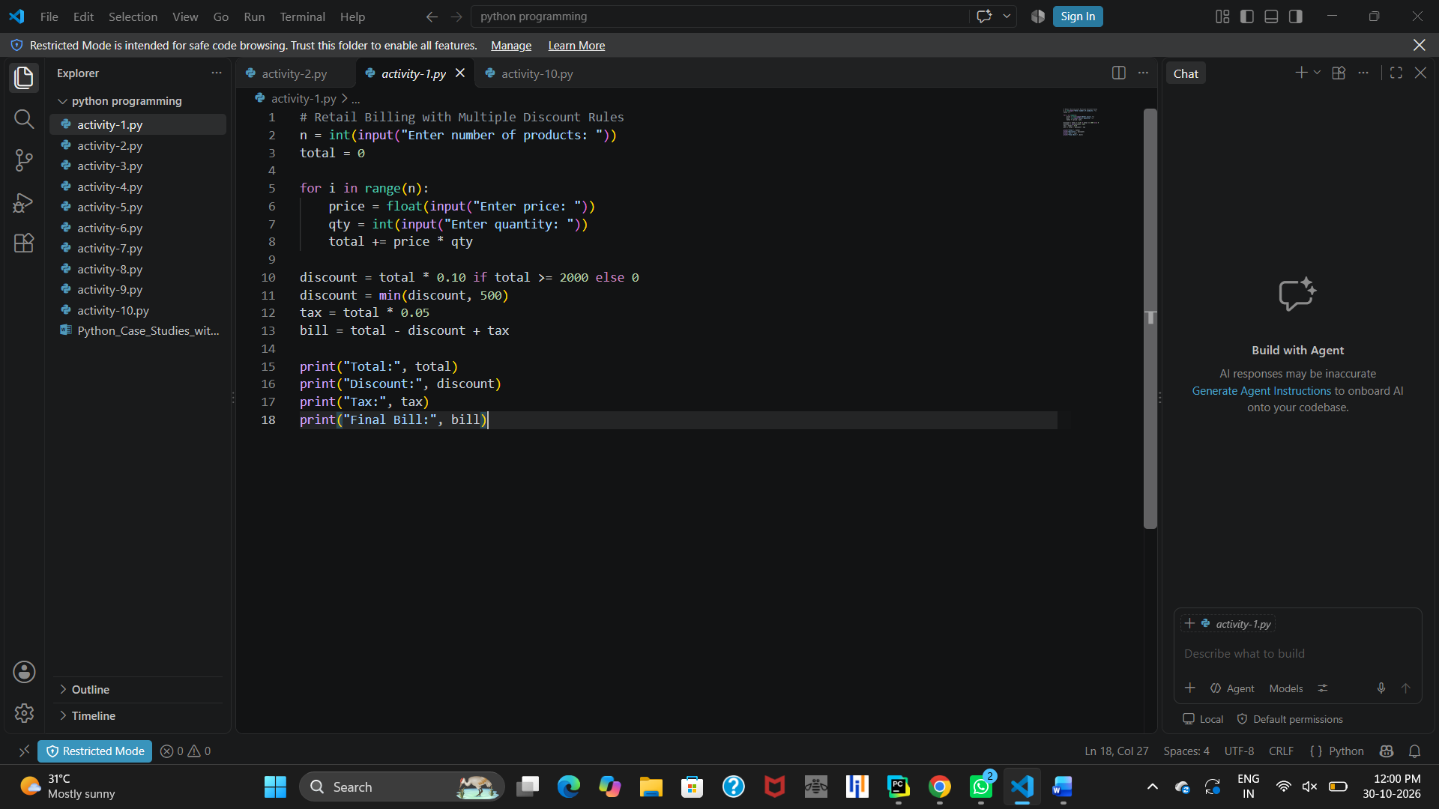10. Conclusion
The Retail Billing System demonstrates how Python can automate billing calculations. It calculates the total amount, applies conditional discounts with a maximum concession limit, calculates tax, and displays the final bill. This program helps students understand loops, conditional statements, arithmetic operations, and input/output functions.
Note: This version follows your exact Python code. It does not include product names or category-specific taxes because those features are not present in the supplied code.

PROGRAM 2

Retail Billing with Multiple Discount Rules

1. Problem Statement
Develop a Python program for a retail shop that accepts multiple products, their prices, and quantities. Calculate the total amount, apply a 10% discount when the total is ₹2,000 or more, limit the maximum discount to ₹500, calculate 5% tax, and display the final bill.

2. Objectives

1. Accept the number of products.

2. Read product prices and quantities.

3. Calculate individual product costs.

4. Calculate the total amount.

5. Apply a 10% discount for purchases of ₹2,000 or more.

6. Limit the maximum discount to ₹500.

7. Calculate 5% tax.

8. Display the final bill.

3. Assumptions

1. The customer purchases at least one product.

2. Product prices and quantities are positive.

3. A 10% discount applies when the total is ₹2,000 or more.

4. The maximum discount is ₹500.

5. Tax is calculated at 5% of the original total.

6. All amounts are in Indian rupees.

4. Algorithm

1. Start.

2. Input the number of products.

3. Initialize total to zero.

4. Repeat for each product:
o Input price and quantity.
o Calculate price × quantity.
o Add the cost to total.

5. Check whether total is at least ₹2,000.

6. Calculate a 10% discount; otherwise, set discount to zero.

7. Limit the discount to ₹500.

8. Calculate tax at 5%.

9. Calculate the final bill.

10. Display total, discount, tax, and final bill.

11. Stop.

5. Flowchart
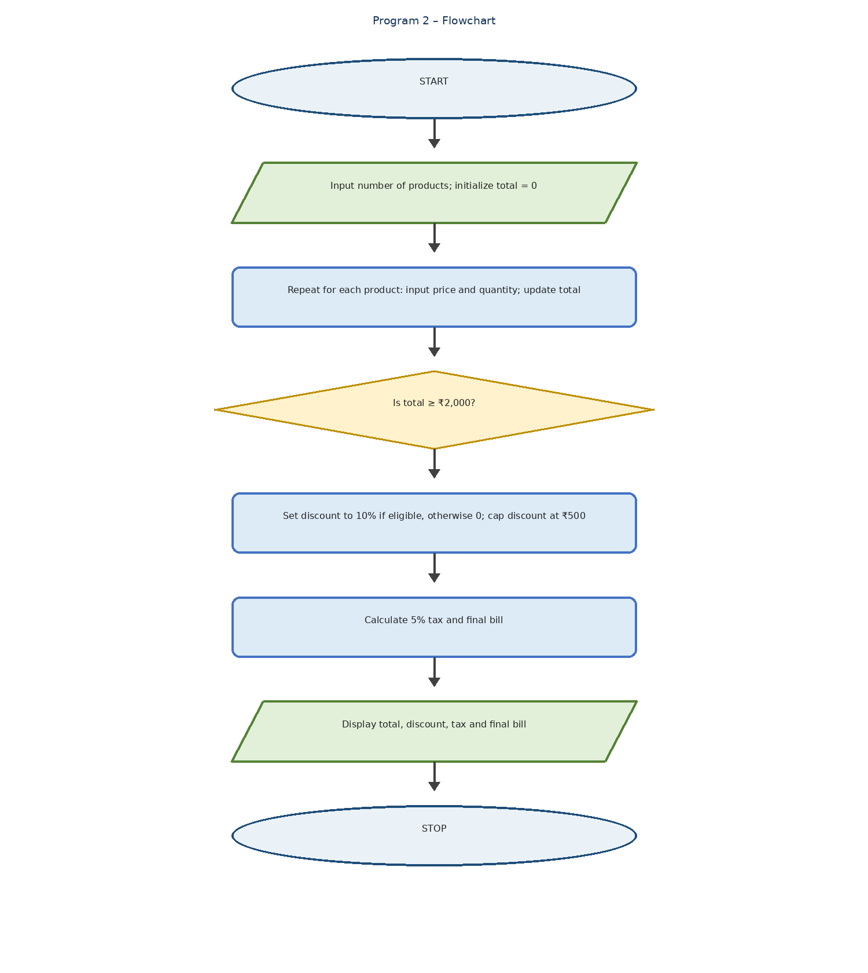
GitHub - inesiameita/Project-Super-Cashier: Super Cashier is a program self service system to record customer's items purchased. · GitHub

6. Pseudocode
START
INPUT n
total = 0
FOR i = 1 TO n
INPUT price
INPUT qty
total = total + price * qty
END FOR
IF total >= 2000
discount = total * 0.10
ELSE
discount = 0
END IF
discount = MIN(discount, 500)
tax = total * 0.05
bill = total - discount + tax
DISPLAY total
DISPLAY discount
DISPLAY tax
DISPLAY bill
STOP

7. Python Source Code
n = int(input("Enter number of products: "))
total = 0
for i in range(n):
price = float(input("Enter price: "))
qty = int(input("Enter quantity: "))
total += price * qty
discount = total * 0.10 if total >= 2000 else 0
discount = min(discount, 500)
tax = total * 0.05
bill = total - discount + tax
print("Total:", total)
print("Discount:", discount)
print("Tax:", tax)
print("Final Bill:", bill)

8. Test Cases
Test Case 1: Purchase below ₹2,000
Input Value
Products 1
Price 500
Quantity 2
Total 1000
Expected output:
Total: 1000.0
Discount: 0
Tax: 50.0
Final Bill: 1050.0
Test Case 2: Purchase above ₹2,000
Input Value
Products 2
Price 1 1200
Quantity 1 1
Price 2 1000
Quantity 2 1
Expected output:
Total: 2200.0
Discount: 220.0
Tax: 110.0
Final Bill: 2090.0
Test Case 3: Maximum discount
Input Value
Products 1
Price 7000
Quantity 1
Expected output:
Total: 7000.0
Discount: 500
Tax: 350.0
Final Bill: 6850.0

9. Output

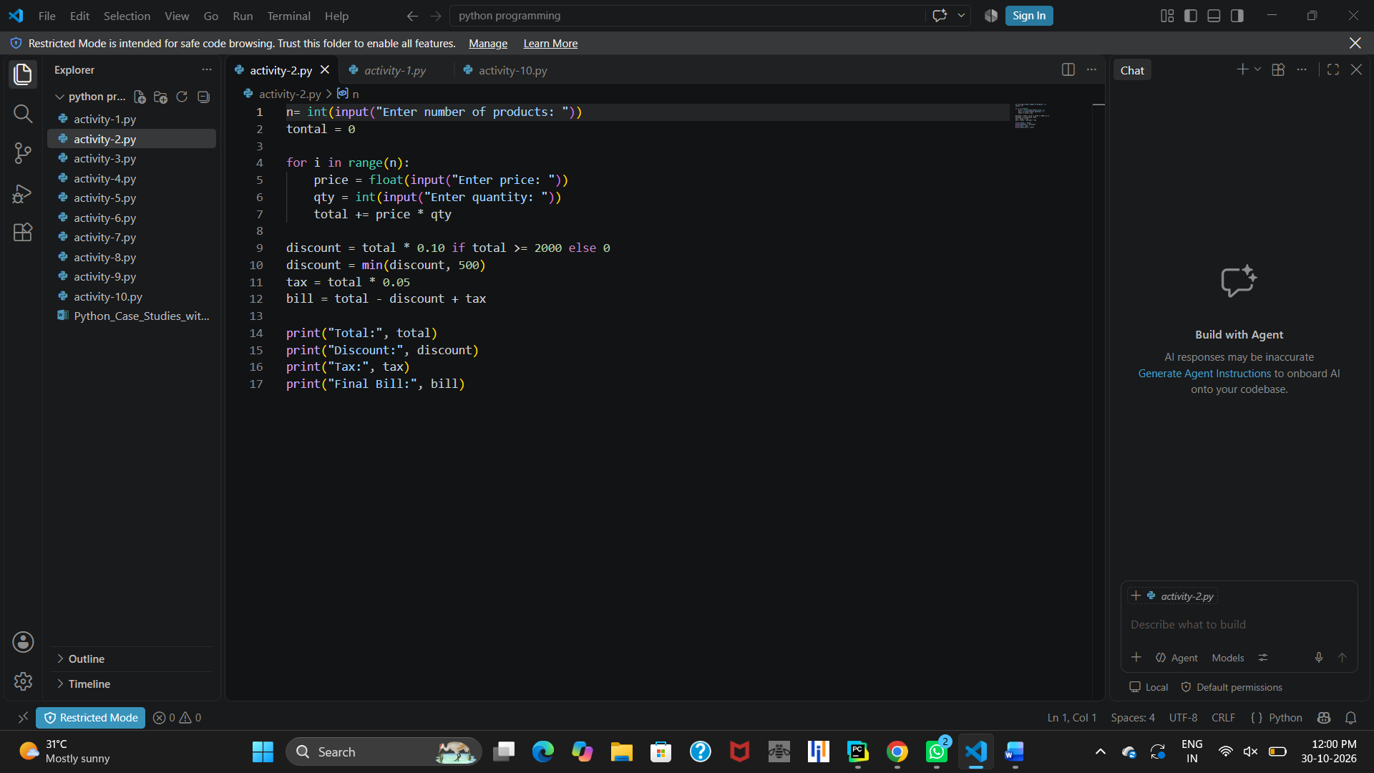10. Conclusion
The Retail Billing System demonstrates how Python is used to automate billing calculations. It calculates the total amount, applies discounts with a maximum concession limit, calculates tax, and displays the final bill. This program helps students understand loops, conditional statements, arithmetic operations, and input/output functions.

PROGRAM 3

Campus Event Financial Planning

1. Problem Statement
Develop a Python program to calculate the total expenses of a campus event, including venue, equipment, catering, transport, and certificate costs. Calculate the sponsorship shortfall and determine the minimum number of participant registrations required to cover the remaining amount.

2. Objectives

1. Accept all event expenses from the user.

2. Calculate the total event cost.

3. Accept the sponsorship amount.

4. Calculate the sponsorship shortfall.

5. Accept the registration fee per participant.

6. Calculate the minimum registrations required to break even.

7. Display the financial details.

3. Assumptions

1. All event costs are non-negative.

2. Sponsorship amount is non-negative.

3. Registration fee per participant must be greater than zero.

4. Each participant pays the same registration fee.

5. The number of registrations is rounded up to the next whole number.

6. All amounts are calculated in Indian rupees.

4. Algorithm

1. Start.

2. Input venue cost.

3. Input equipment cost.

4. Input catering cost.

5. Input transport cost.

6. Input certificate cost.

7. Input sponsorship amount.

8. Input registration fee per participant.

9. Calculate total event cost by adding all expenses.

10. Calculate sponsorship shortfall using the maximum of zero and total cost minus sponsorship.

11. Calculate the minimum number of registrations required.

12. Display total cost, sponsorship shortfall, participant contribution, and minimum registrations.

13. Stop.

5. Flowchart
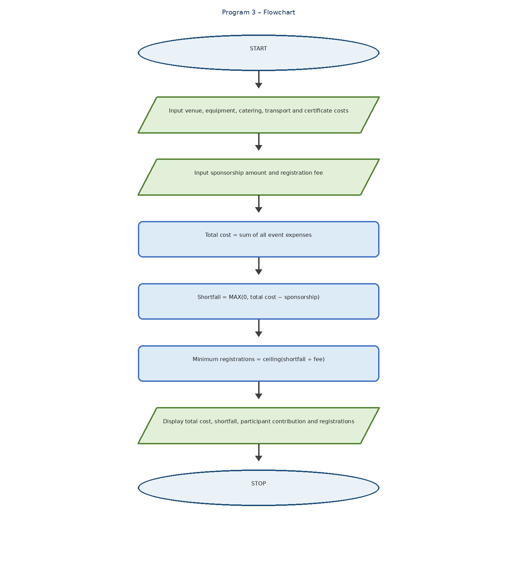
Event Toolkit | Faculty | Health & Human Sciences | Texas Tech

6. Pseudocode
START
INPUT venue
INPUT equipment
INPUT catering
INPUT transport
INPUT certificates
INPUT sponsor
INPUT fee
total = venue + equipment + catering
+ transport + certificates
shortfall = MAX(0, total - sponsor)
participants = CEILING(shortfall / fee)
DISPLAY total
DISPLAY shortfall
DISPLAY shortfall as participant contribution
DISPLAY participants
STOP

7. Python Source Code
venue = float(input("Enter venue cost: "))
equipment = float(input("Enter equipment cost: "))
catering = float(input("Enter catering cost: "))
transport = float(input("Enter transport cost: "))
certificates = float(input("Enter certificate cost: "))
sponsor = float(input("Enter sponsorship amount: "))
fee = float(input("Enter registration fee per participant: "))
total = venue + equipment + catering + transport + certificates
shortfall = max(0, total - sponsor)
participants = int(shortfall / fee) + (shortfall % fee > 0)
print("Total Cost:", total, "\nSponsorship Shortfall:", shortfall)
print("Participant Contribution Needed:", shortfall)
print("Minimum Registrations to Break Even:", participants)

8. Test Cases
Test Case 1: Sponsorship is insufficient
Input Value
Total cost ₹50,000
Sponsorship ₹20,000
Registration fee ₹500
Expected output:
Total Cost: 50000
Sponsorship Shortfall: 30000
Participant Contribution Needed: 30000
Minimum Registrations to Break Even: 60
Test Case 2: Sponsorship covers all expenses
Input Value
Total cost ₹30,000
Sponsorship ₹30,000
Registration fee ₹500
Expected output:
Total Cost: 30000
Sponsorship Shortfall: 0
Participant Contribution Needed: 0
Minimum Registrations to Break Even: 0
Test Case 3: Partial registration fee
Input Value
Total cost ₹10,000
Sponsorship ₹8,800
Registration fee ₹500
Expected output:
Total Cost: 10000
Sponsorship Shortfall: 1200
Participant Contribution Needed: 1200
Minimum Registrations to Break Even: 3

9. Output

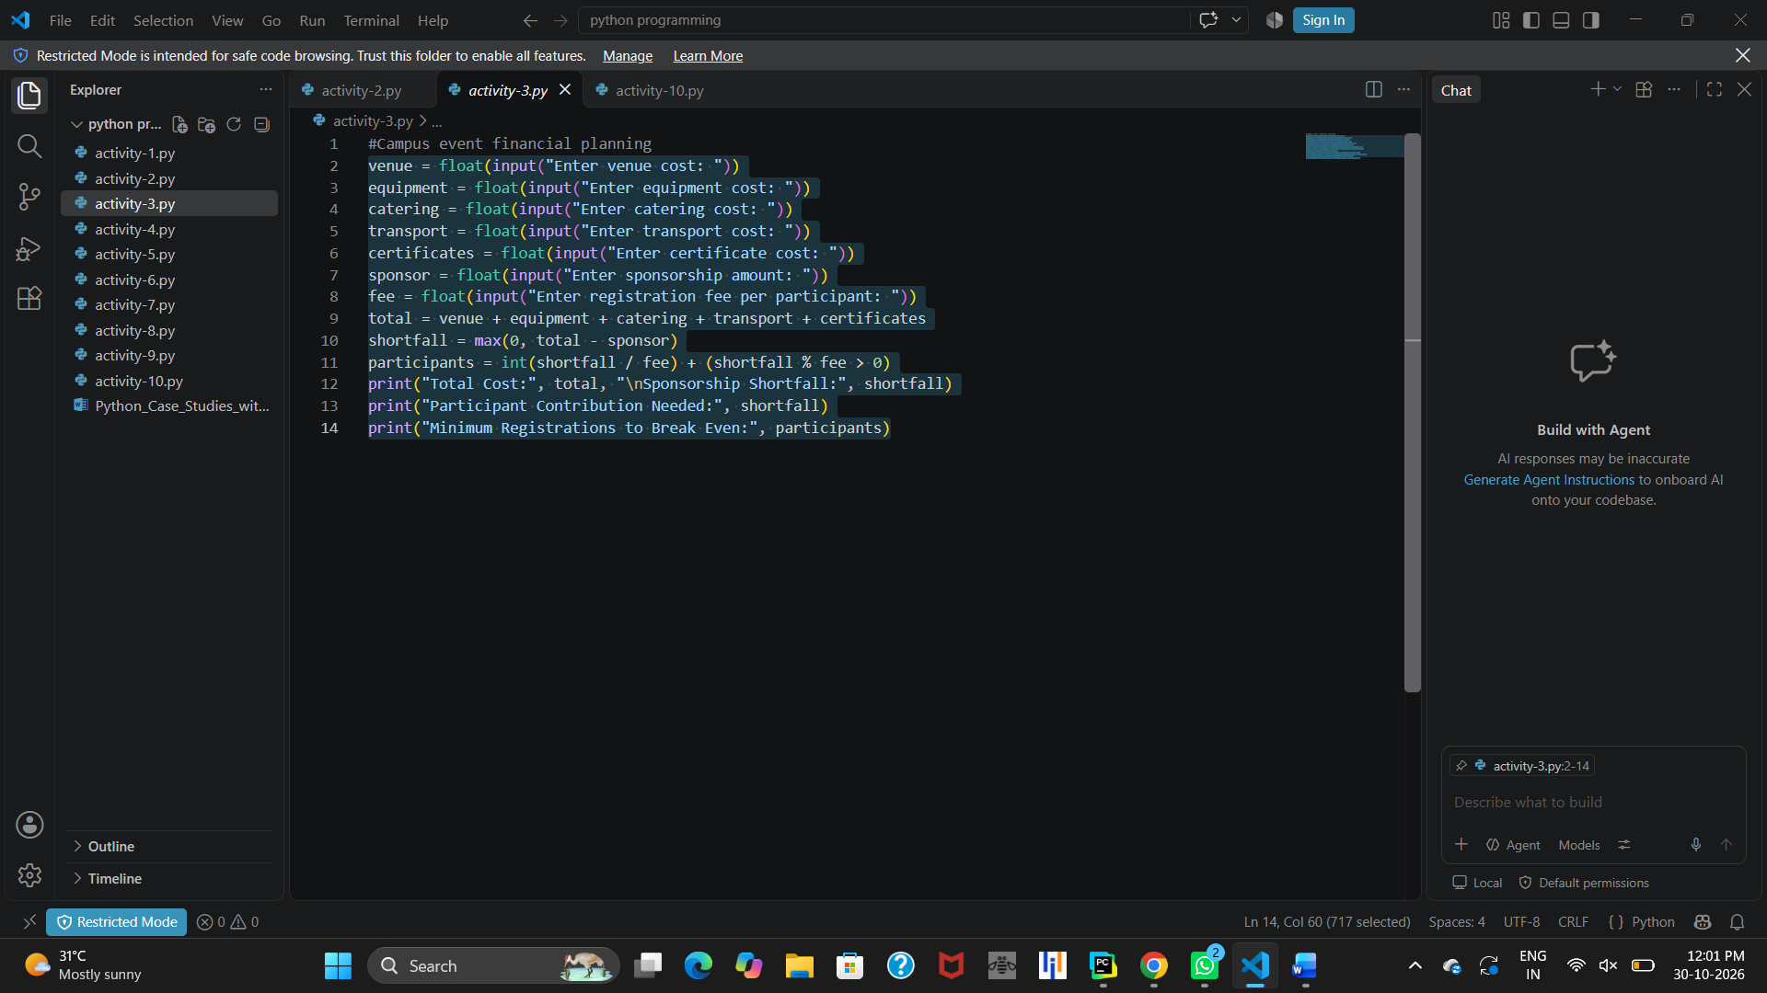10. Conclusion
The Campus Event Financial Planning program calculates total event expenses, sponsorship shortfall, and minimum participant registrations required to cover the remaining cost. It demonstrates Python arithmetic operations, user input, built-in functions, and conditional calculations.

PROGRAM 4

Student Eligibility for Final Examination

1. Problem Statement
A college needs to check whether a student is eligible to attend the final examination. Eligibility depends on attendance percentage, lab completion, internal marks, and fee payment. Write a Python program to check these conditions and display the reasons for ineligibility or confirm eligibility.

2. Objectives
- To check the student's attendance percentage.
- To verify whether the lab work is completed.
- To check the internal marks.
- To verify whether the fees are cleared.
- To display the final examination eligibility status.

3. Assumptions
- Minimum attendance required is 75%.
- Lab completion must be "yes".
- Minimum internal marks required are 40.
- Fees must be cleared ("yes").
- Inputs are entered in the correct format.
- The program uses lowercase "yes" and "no".

4. Algorithm

1. Start the program.

2. Read the student's attendance percentage.

3. Read the lab completion status.

4. Read the internal marks.

5. Read the fee payment status.

6. If attendance is below 75, display "Attendance shortage".

7. If lab is not completed, display "Lab not completed".

8. If internal marks are below 40, display "Internal marks insufficient".

9. If fees are not cleared, display "Fees not cleared".

10. If all conditions are satisfied, display "Eligible for final examination".

11. Stop the program.

5. Flowchart
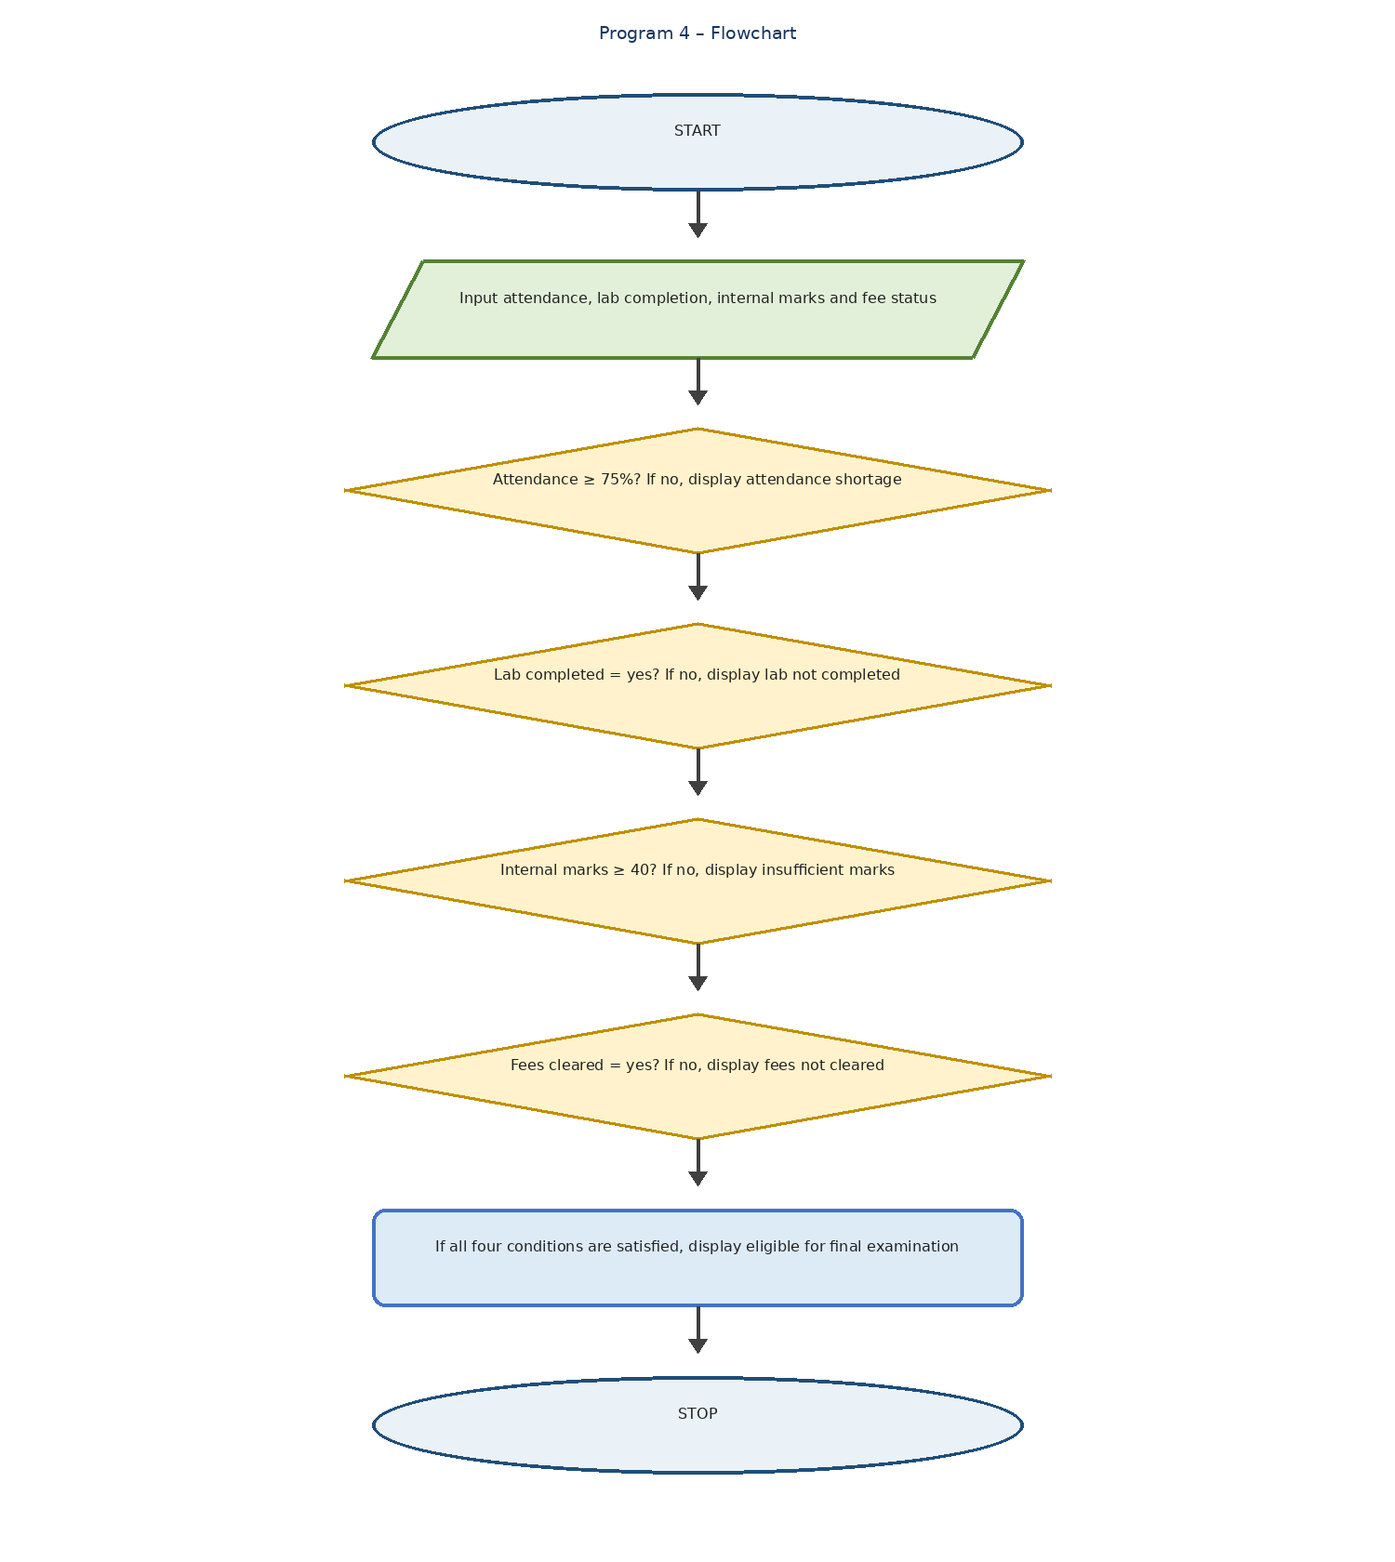
Mastering Python Conditional Statements: A Step-by-Step Guide | by Dinesh Suthar | Medium
Flowchart symbols:
- Oval – Start and Stop
- Parallelogram – Input and Output
- Diamond – Decision
- Rectangle – Processing

6. Pseudocode
START
INPUT attendance
INPUT lab
INPUT internal
INPUT fees
IF attendance < 75
PRINT "Attendance shortage"
END IF
IF lab != "yes"
PRINT "Lab not completed"
END IF
IF internal < 40
PRINT "Internal marks insufficient"
END IF
IF fees != "yes"
PRINT "Fees not cleared"
END IF
IF attendance >= 75 AND lab == "yes"
AND internal >= 40 AND fees == "yes"
PRINT "Eligible for final examination"
END IF
STOP

7. Python Source Code
attendance = int(input("Enter attendance %: "))
lab = input("Lab completed (yes/no): ")
internal = int(input("Enter internal marks: "))
fees = input("Fees cleared (yes/no): ")
if attendance < 75:
print("Attendance shortage")
if lab != "yes":
print("Lab not completed")
if internal < 40:
print("Internal marks insufficient")
if fees != "yes":
print("Fees not cleared")
if attendance >= 75 and lab == "yes" and internal >= 40 and fees == "yes":
print("Eligible for final examination")

8. Test Cases
Test Case Attendance Lab Internal Fees Expected Result
1 85 yes 75 yes Eligible
2 65 yes 60 yes Attendance shortage
3 80 no 70 yes Lab not completed
4 90 yes 30 yes Internal marks insufficient
5 80 yes 60 no Fees not cleared

9. Output

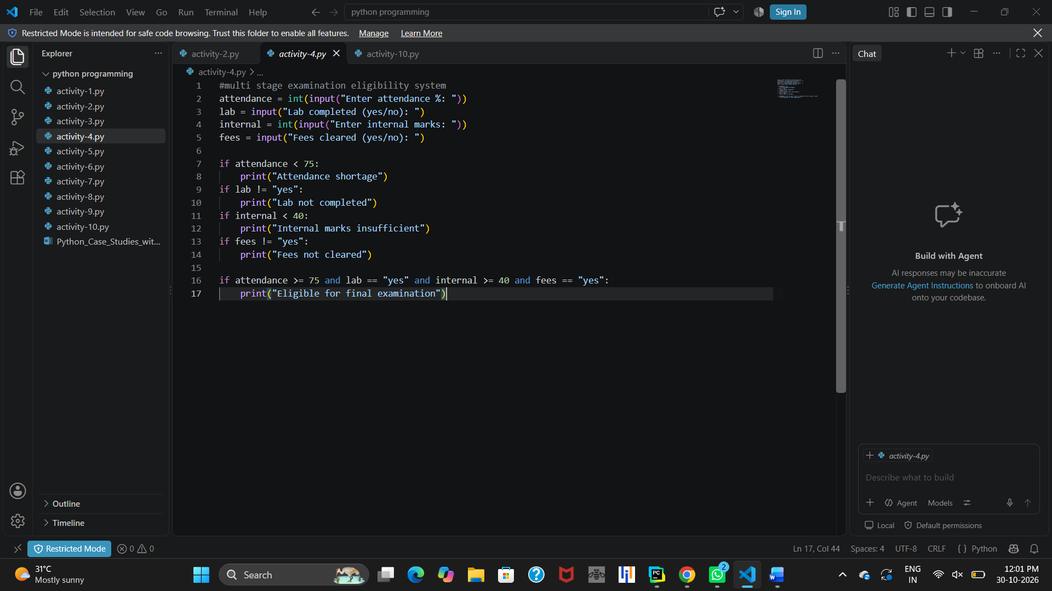10. Conclusion
This Python program checks student eligibility for the final examination using conditional statements. It verifies attendance, lab completion, internal marks, and fee payment. It displays the reasons if a student is not eligible and confirms eligibility when all conditions are satisfied.

PROGRAM 5

Passenger Counting System

1. Problem Statement
A bus travels through three stops. At each stop, some passengers board the bus and some passengers leave the bus. Write a Python program to calculate the total number of passengers remaining in the bus after visiting all three stops.

2. Objectives
- To calculate the number of passengers boarding the bus.
- To calculate the number of passengers leaving the bus.
- To update the passenger count at each stop.
- To display the total number of passengers after three stops.
- To understand the use of loops and arithmetic operations in Python.

3. Assumptions
- The bus visits exactly three stops.
- Passenger boarding and leaving values are entered as integers.
- The initial number of passengers is zero.
- The number of passengers leaving should not exceed the passengers currently on the bus.
- Passenger counts cannot be negative.

4. Algorithm

1. Start the program.

2. Initialize the passenger count to zero.

3. Repeat the following steps for three stops:
o Read the number of passengers boarding.
o Read the number of passengers leaving.
o Add boarding passengers to the total.
o Subtract leaving passengers from the total.

4. Display the total number of passengers.

5. Stop the program.

5. Flowchart
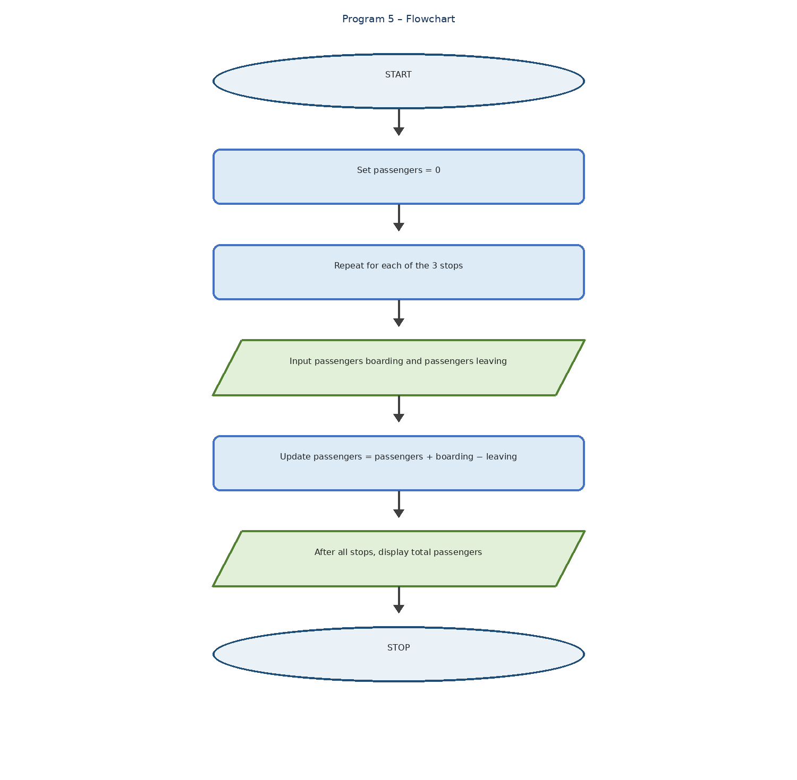
Chapter 11-PCP.pdf
Flowchart symbols:
- Oval – Start and Stop
- Parallelogram – Input and Output
- Rectangle – Process or calculation
- Diamond – Loop condition

6. Pseudocode
START
SET passengers = 0
FOR stop = 0 TO 2
INPUT board
INPUT leave
passengers = passengers + board - leave
END FOR
PRINT passengers
STOP

7. Python Source Code
passengers = 0
for stop in range(3):
board = int(input("Passengers boarding: "))
leave = int(input("Passengers leaving: "))
passengers = passengers + board - leave
print("Total passengers:", passengers)

8. Test Cases
Test Case Boarding at 3 stops Leaving at 3 stops Expected Total
1 10, 5, 8 2, 3, 4 14
2 20, 10, 5 5, 10, 5 15
3 15, 10, 5 5, 5, 5 15

9. Output

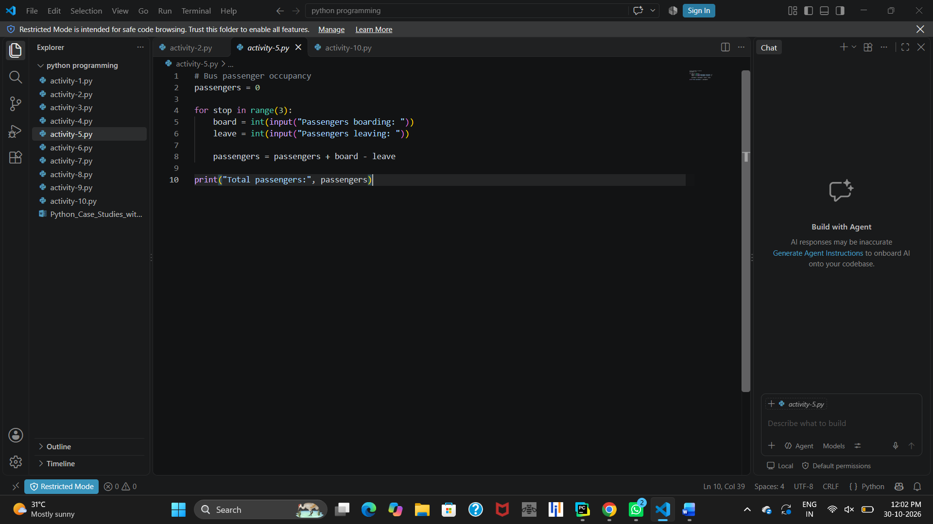10. Conclusion
This Python program calculates the total number of passengers in a bus after three stops. It uses a for loop to repeat the process and arithmetic operations to update the passenger count. It helps in understanding loops, variables, input, and output in Python.

PROGRAM 6

Electricity or Water Usage Savings Calculation

1. Problem Statement
A user wants to calculate the units saved by comparing usage before and after taking saving measures. Write a Python program to calculate the units saved and the percentage of savings. If the previous usage is zero, display a message that the percentage cannot be calculated.

2. Objectives
- To accept usage before and after saving measures.
- To calculate the units saved.
- To calculate the percentage of savings.
- To check whether the previous usage is greater than zero.
- To display the results using Python.

3. Assumptions
- Usage values are entered as integers.
- The before and after usage values are non-negative.
- The previous usage is used as the base for percentage calculation.
- Percentage is calculated only when the previous usage is greater than zero.
- Savings can be positive, zero, or negative.

4. Algorithm

1. Start the program.

2. Read the usage before saving measures.

3. Read the usage after saving measures.

4. Calculate units saved by subtracting after usage from before usage.

5. Display the units saved.

6. Check whether the before usage is greater than zero.

7. If true:
o Calculate the percentage saved.
o Display the percentage saved.

8. Otherwise, display "Cannot calculate percentage".

9. Stop the program.

5. Flowchart
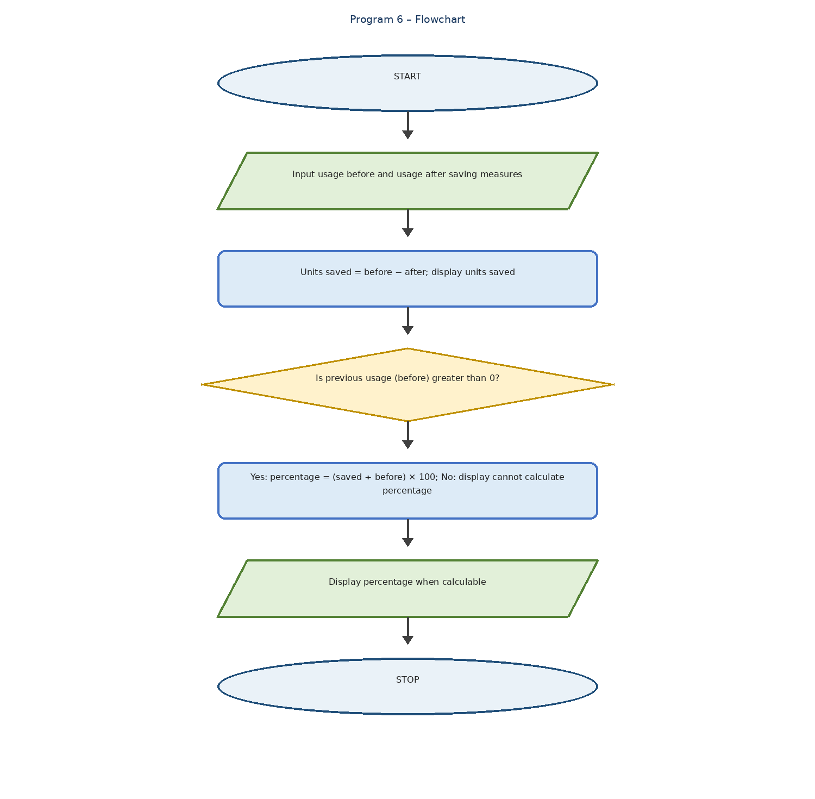
Comprehensive Code Algorithm & Logic Breakdown | Bobr AI
Flowchart symbols:
- Oval – Start and Stop
- Parallelogram – Input and Output
- Rectangle – Calculation or Processing
- Diamond – Decision

6. Pseudocode
START
INPUT before
INPUT after
saved = before - after
PRINT saved
IF before > 0 THEN
percent = (saved / before) * 100
PRINT percent
ELSE
PRINT "Cannot calculate percentage"
END IF
STOP

7. Python Source Code
before = int(input("Usage before: "))
after = int(input("Usage after: "))
saved = before - after
print("Units saved:", saved)
if before > 0:
percent = saved / before * 100
print("Percentage saved:", percent)
else:
print("Cannot calculate percentage")

8. Test Cases
Test Case Before Usage After Usage Units Saved Expected Result
1 100 60 40 40% saved
2 200 150 50 25% saved
3 100 100 0 0% saved
4 0 0 0 Cannot calculate percentage
5 80 100 -20 -25% saved

9. Output

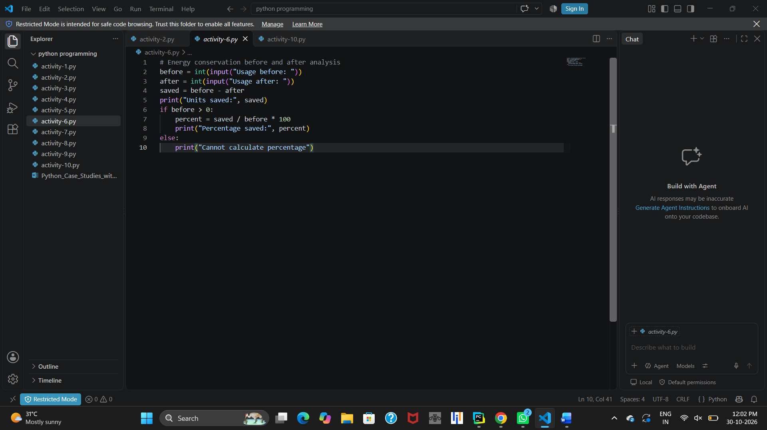10. Conclusion
This Python program calculates the units saved and percentage of savings by comparing usage before and after. It uses arithmetic operations and an if-else condition to calculate and display the results. It also handles the case where the previous usage is zero.

PROGRAM 7

Student Academic Progression Eligibility

1. Problem Statement
A college wants to check whether a student is eligible for academic progression to the next semester. Eligibility depends on semester marks, attendance percentage, and completion of prerequisite subjects. Write a Python program to check these conditions and display the reasons for ineligibility or confirm eligibility for progression.

2. Objectives
- To check the student's semester marks.
- To verify the attendance percentage.
- To check whether prerequisite subjects are completed.
- To identify the reasons for ineligibility.
- To display the final academic progression status.

3. Assumptions
- Minimum passing marks are 40.
- Minimum attendance required is 75%.
- All prerequisite subjects must be completed.
- Prerequisite status is entered as "yes" or "no" in lowercase.
- Marks and attendance are entered as integers.

4. Algorithm

1. Start the program.

2. Read the semester marks.

3. Read the attendance percentage.

4. Read the prerequisite completion status.

5. If marks are below 40, display "Subject not passed".

6. If attendance is below 75, display "Attendance shortage".

7. If prerequisites are not completed, display "Prerequisites incomplete".

8. Check whether all three conditions are satisfied.

9. If all conditions are satisfied, display "Eligible for progression".

10. Stop the program.

5. Flowchart
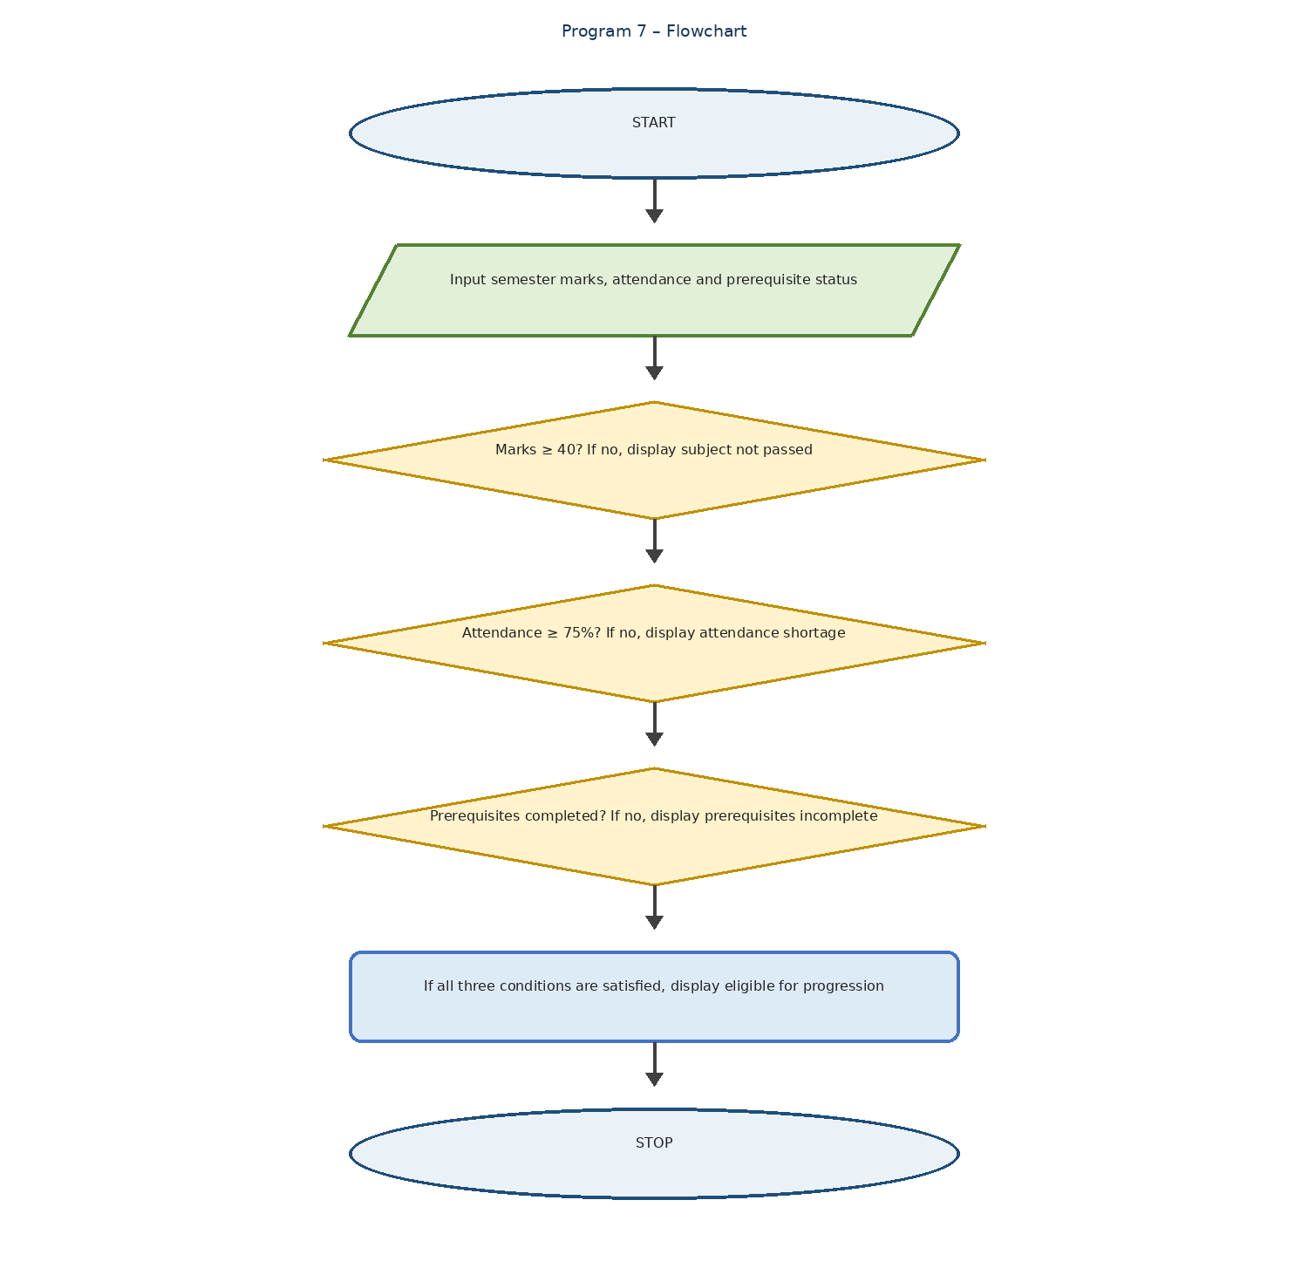
C program to check whether the given marks are pass or fail | by VIGNESWARAN.S | Medium
vigneswaran2510.medium.com
Flowchart symbols:
- Oval – Start and Stop
- Parallelogram – Input and Output
- Diamond – Decision
- Rectangle – Processing

6. Pseudocode
START
INPUT marks
INPUT attendance
INPUT prereq
IF marks < 40
PRINT "Subject not passed"
END IF
IF attendance < 75
PRINT "Attendance shortage"
END IF
IF prereq != "yes"
PRINT "Prerequisites incomplete"
END IF
IF marks >= 40 AND attendance >= 75
AND prereq == "yes"
PRINT "Eligible for progression"
END IF
STOP

7. Python Source Code
marks = int(input("Enter semester marks: "))
attendance = int(input("Enter attendance %: "))
prereq = input("Prerequisites completed (yes/no): ")
if marks < 40:
print("Subject not passed")
if attendance < 75:
print("Attendance shortage")
if prereq != "yes":
print("Prerequisites incomplete")
if marks >= 40 and attendance >= 75 and prereq == "yes":
print("Eligible for progression")

8. Test Cases
Test Case Marks Attendance Prerequisites Expected Result
1 75 85 yes Eligible for progression
2 30 80 yes Subject not passed
3 65 60 yes Attendance shortage
4 70 85 no Prerequisites incomplete
5 30 60 no All three ineligibility messages

9. Output

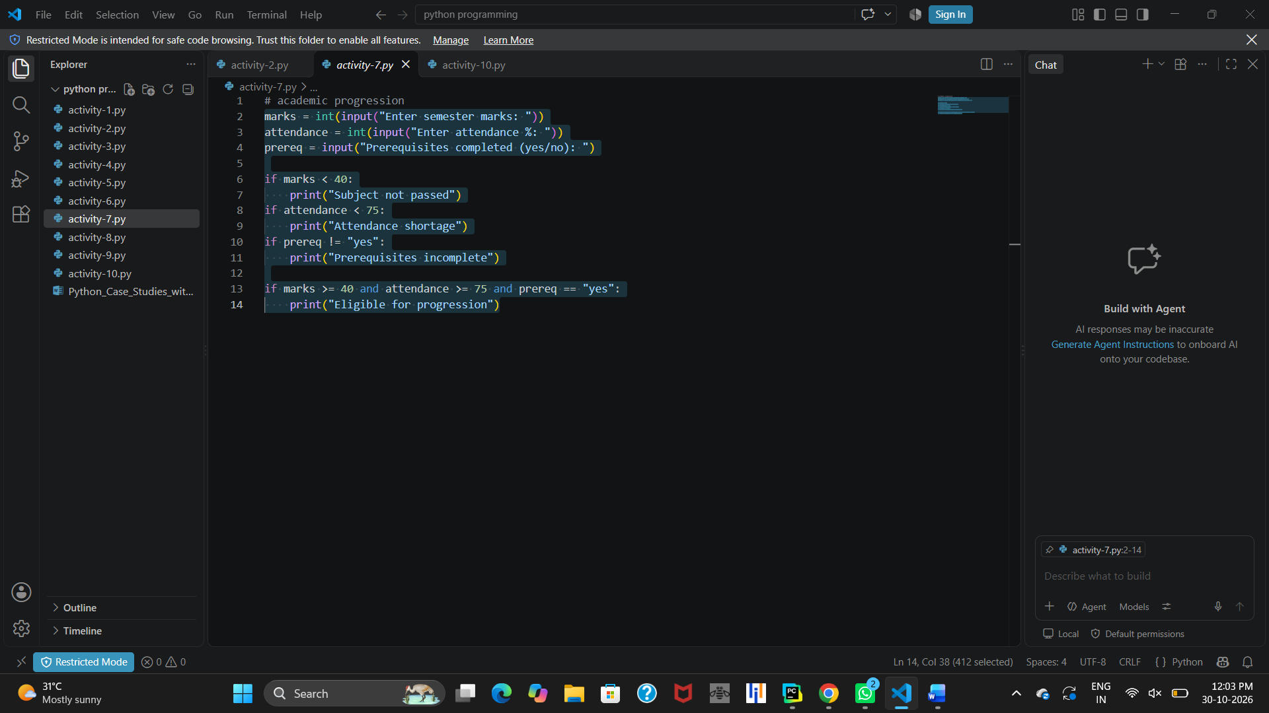10. Conclusion
This Python program checks a student's academic progression eligibility using conditional statements. It verifies semester marks, attendance, and prerequisite completion. It displays the reasons for ineligibility or confirms eligibility when all conditions are satisfied.

PROGRAM 8

Classroom Seating Arrangement Using Nested Loops

1. Problem Statement
A classroom has 7 rows and 4 columns of seats. Write a Python program to display the seating arrangement using nested loops. One particular seat (row 2, column 2) is marked as "Reserved". The remaining seats are displayed based on an even or odd condition using row and column positions.

2. Objectives
- To display a classroom seating arrangement.
- To use nested for loops in Python.
- To identify a reserved seat.
- To display seat numbers based on row and column positions.
- To understand conditional statements and formatting output.

3. Assumptions
- The classroom contains 7 rows and 4 columns.
- The seat at row 2, column 2 is reserved.
- Row and column numbering starts from 1 in the displayed output.
- Seats satisfying the even-sum condition are displayed with seat numbers.
- Other seats are displayed using "--".

4. Algorithm

1. Start the program.

2. Initialize rows = 7 and cols = 4.

3. Use an outer for loop to iterate through 7 rows.

4. Use an inner for loop to iterate through 4 columns.

5. Check whether the current position is (1, 1).

6. If true, display "Reserved".

7. Otherwise, check whether the sum of row and column indices is even.

8. If even, display the seat number.

9. Otherwise, display "--".

10. Move to the next line after completing each row.

11. Stop the program.

5. Flowchart
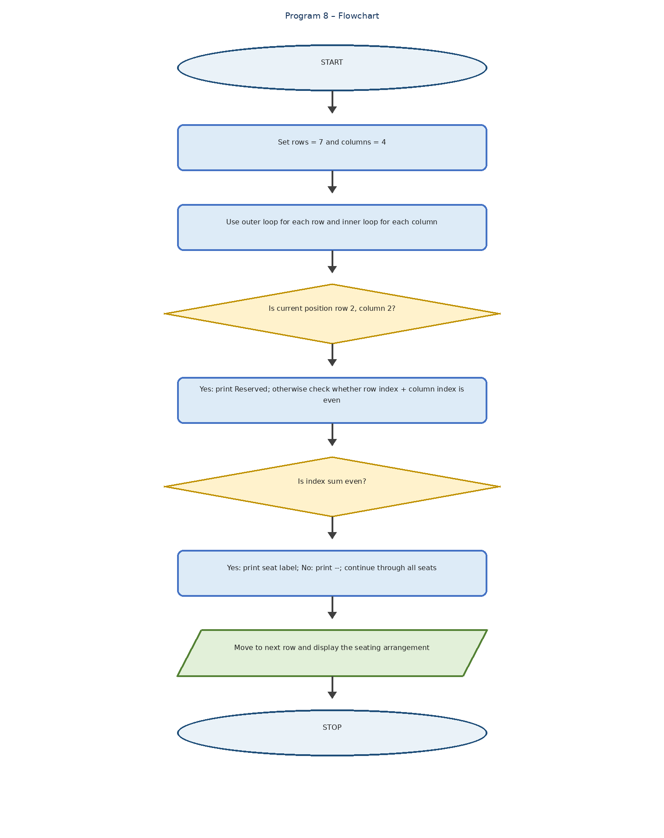
Bot Verification
Flowchart symbols:
- Oval – Start and Stop
- Rectangle – Initialization and processing
- Diamond – Decision
- Parallelogram – Output
- Arrow – Flow direction

6. Pseudocode
START
SET rows = 7
SET cols = 4
FOR i = 0 TO rows-1
FOR j = 0 TO cols-1
IF i == 1 AND j == 1
PRINT "Reserved"
ELSE IF (i + j) MOD 2 == 0
PRINT "R", i+1, "C", j+1
ELSE
PRINT "--"
END IF
END FOR
MOVE TO NEXT LINE
END FOR
STOP

7. Python Source Code
rows = 7
cols = 4
for i in range(rows):
for j in range(cols):
if (i, j) == (1, 1):
print("Reserved", end="\t")
elif (i + j) % 2 == 0:
print(f"R{i+1}C{j+1}", end="\t")
else:
print("--", end="\t")
print()

8. Test Cases
Test Case Row Column Condition Expected Output
1 1 1 Even sum R1C1
2 2 2 Reserved position Reserved
3 1 2 Odd sum --
4 3 3 Even sum R3C3
5 7 4 Odd sum --

9. Output

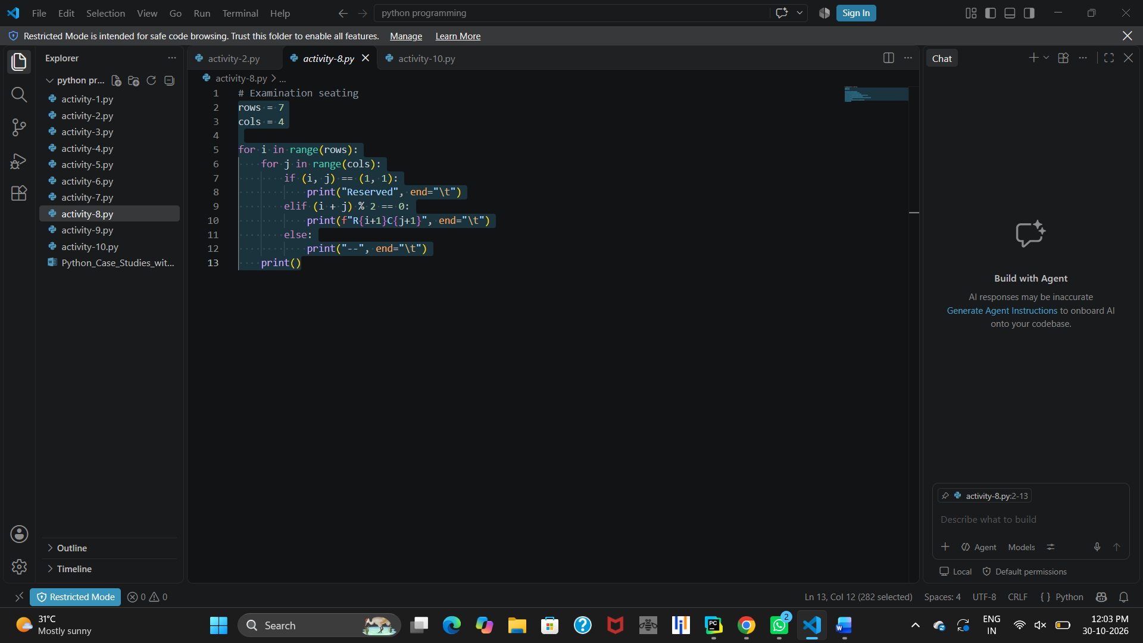10. Conclusion
This Python program displays a classroom seating arrangement using nested for loops and conditional statements. It identifies a reserved seat and displays other seats based on even and odd conditions. It helps in understanding nested loops, tuples, conditions, and formatted output in Python.

PROGRAM 9

Inventory and Stock Management System

1. Problem Statement
A college maintains stock at three locations: College, Hostel, and Canteen. The stock received, distributed, and damaged is recorded at each location. Write a Python program to calculate the remaining stock and identify whether replenishment is needed or a stock discrepancy has occurred.

2. Objectives
- To maintain stock details at different locations.
- To calculate the remaining stock.
- To identify locations that need replenishment.
- To detect stock discrepancies.
- To understand the use of lists, loops, and conditional statements in Python.

3. Assumptions
- There are three locations: College, Hostel, and Canteen.
- Received, distributed, and damaged quantities are entered as integers.
- Remaining stock is calculated by subtracting distributed and damaged quantities from received quantity.
- The minimum required stock is 10 units.
- If remaining stock is negative, a stock discrepancy is displayed.

4. Algorithm

1. Start the program.

2. Create a list containing College, Hostel, and Canteen.

3. Use a for loop to visit each location.

4. Read the quantity received.

5. Read the quantity distributed.

6. Read the quantity damaged.

7. Calculate remaining stock.

8. Display the location and remaining stock.

9. If remaining stock is less than 10:
o Calculate the quantity required for replenishment.
o Display the replenishment quantity.

10. If remaining stock is negative, display "Stock discrepancy detected".

11. Repeat the process for all locations.

12. Stop the program.

5. Flowchart
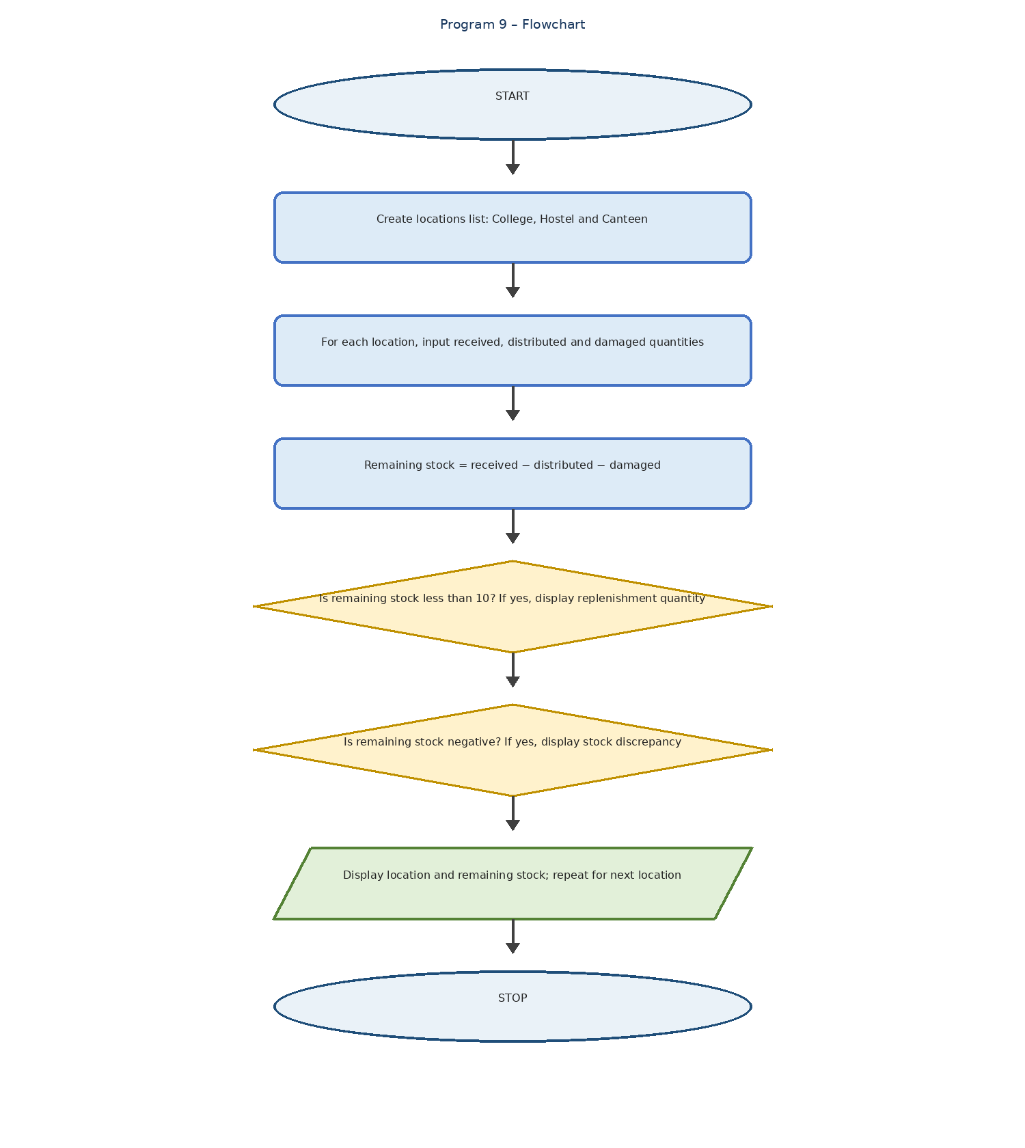
What is inventory management | 2024
Flowchart symbols:
- Oval – Start and Stop
- Parallelogram – Input and Output
- Rectangle – Calculation or Processing
- Diamond – Decision
- Arrow – Flow direction

6. Pseudocode
START
SET locations = ["College", "Hostel", "Canteen"]
FOR each place in locations
INPUT received
INPUT distributed
INPUT damaged
remaining = received - distributed - damaged
PRINT place, remaining
IF remaining < 10
PRINT "Replenishment needed:", 10 - remaining
END IF
IF remaining < 0
PRINT "Stock discrepancy detected"
END IF
END FOR
STOP

7. Python Source Code
locations = ["College", "Hostel", "Canteen"]
for place in locations:
received = int(input("Quantity received: "))
distributed = int(input("Quantity distributed: "))
damaged = int(input("Quantity damaged: "))
remaining = received - distributed - damaged
print(place, "Remaining:", remaining)
if remaining < 10:
print("Replenishment needed:", 10 - remaining)
if remaining < 0:
print("Stock discrepancy detected")

8. Test Cases
Test Case Location Received Distributed Damaged Remaining
1 College 100 60 5 35
2 Hostel 50 45 2 3
3 Canteen 30 20 15 -5
Expected results:
- College: No replenishment needed.
- Hostel: Replenishment of 7 units needed.
- Canteen: Replenishment of 15 units needed and stock discrepancy detected.

9. Output

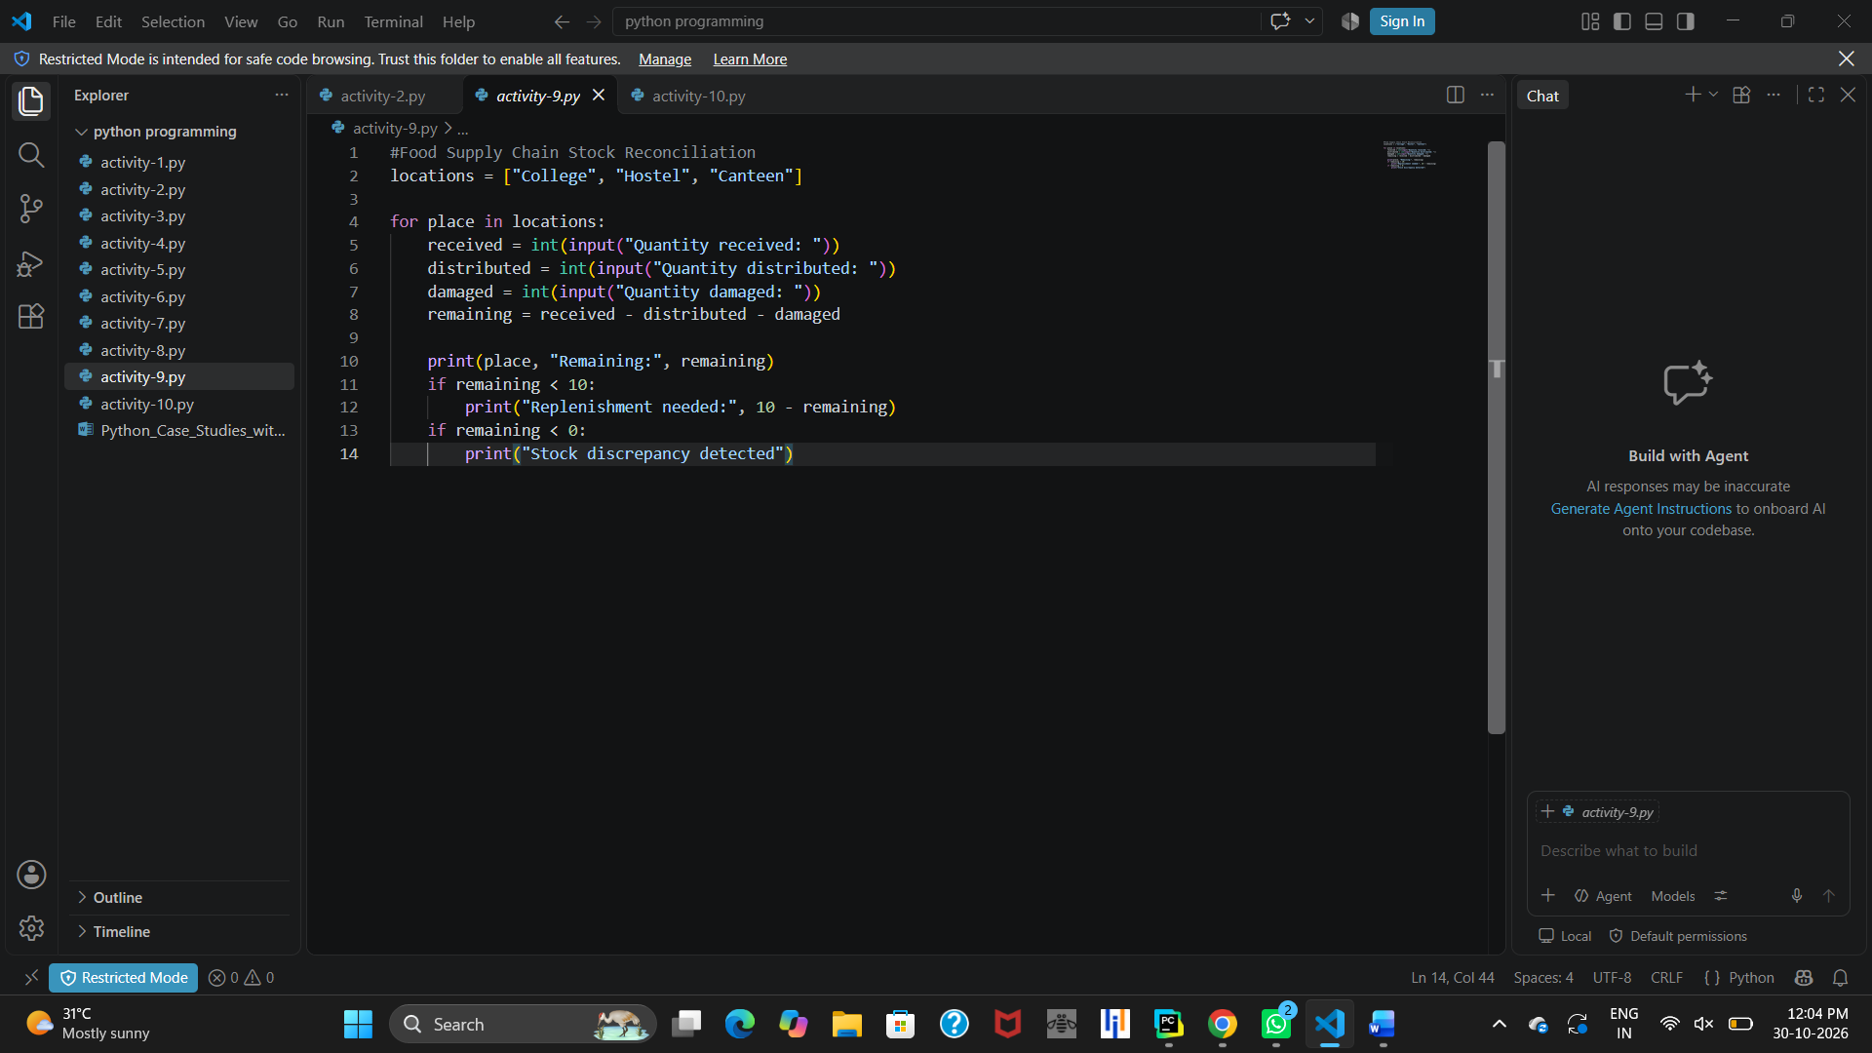10. Conclusion
This Python program manages stock at different locations using a list and a for loop. It calculates remaining stock and uses conditional statements to identify replenishment requirements and stock discrepancies. It helps in understanding lists, loops, arithmetic operations, and decision-making in Python.

PROGRAM 10

Inventory and Stock Management System

1. Problem Statement
A college maintains stock at three different locations: College, Hostel, and Canteen. The quantities received, distributed, and damaged are recorded at each location. Write a Python program to calculate the remaining stock and identify whether replenishment is required or a stock discrepancy has occurred.

2. Objectives
- To maintain stock details at different locations.
- To calculate the remaining stock.
- To identify locations that need replenishment.
- To detect stock discrepancies.
- To understand lists, loops, and conditional statements in Python.

3. Assumptions
- There are three locations: College, Hostel, and Canteen.
- All quantities are entered as integers.
- The initial stock is considered through the received quantity.
- Minimum required stock is 10 units.
- Negative remaining stock indicates a stock discrepancy.

4. Algorithm

1. Start the program.

2. Create a list containing College, Hostel, and Canteen.

3. Use a for loop to visit each location.

4. Read the quantity received.

5. Read the quantity distributed.

6. Read the quantity damaged.

7. Calculate the remaining stock using:
Remaining = Received − Distributed − Damaged

8. Display the location and remaining stock.

9. If remaining stock is less than 10, calculate and display the replenishment quantity.

10. If remaining stock is negative, display "Stock discrepancy detected".

11. Repeat the process for all locations.

12. Stop the program.

5. Flowchart
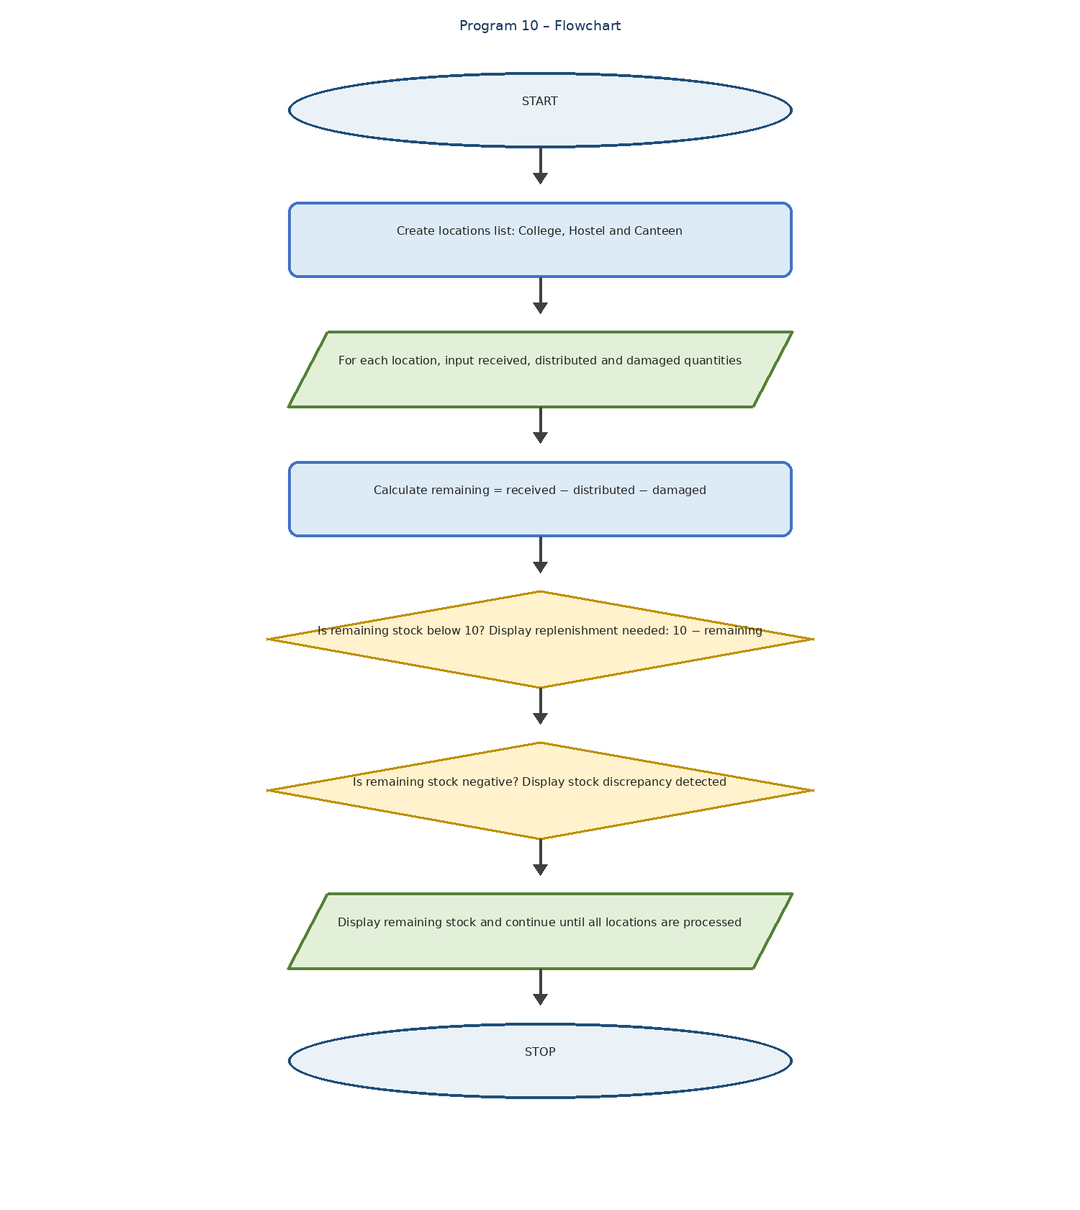
Diagrama de flujo Entradas - Estadía profesional - inicio SI ¿Mercancía dañada? NO INICIO FIN - Studocu
Flowchart symbols:
- Oval – Start and Stop
- Parallelogram – Input and Output
- Rectangle – Calculation or Processing
- Diamond – Decision
- Arrow – Flow direction

6. Pseudocode
START
SET locations = ["College", "Hostel", "Canteen"]
FOR each place in locations
INPUT received
INPUT distributed
INPUT damaged
remaining = received - distributed - damaged
PRINT place, "Remaining:", remaining
IF remaining < 10
PRINT "Replenishment needed:", 10 - remaining
END IF
IF remaining < 0
PRINT "Stock discrepancy detected"
END IF
END FOR
STOP

7. Python Source Code
locations = ["College", "Hostel", "Canteen"]
for place in locations:
received = int(input("Quantity received: "))
distributed = int(input("Quantity distributed: "))
damaged = int(input("Quantity damaged: "))
remaining = received - distributed - damaged
print(place, "Remaining:", remaining)
if remaining < 10:
print("Replenishment needed:", 10 - remaining)
if remaining < 0:
print("Stock discrepancy detected")

8. Test Cases
Test Case Location Received Distributed Damaged Remaining
1 College 100 60 5 35
2 Hostel 50 45 2 3
3 Canteen 30 20 15 -5
Expected Results:
- College: No replenishment needed.
- Hostel: Replenishment needed – 7 units.
- Canteen: Replenishment needed – 15 units and stock discrepancy detected.

9. Output
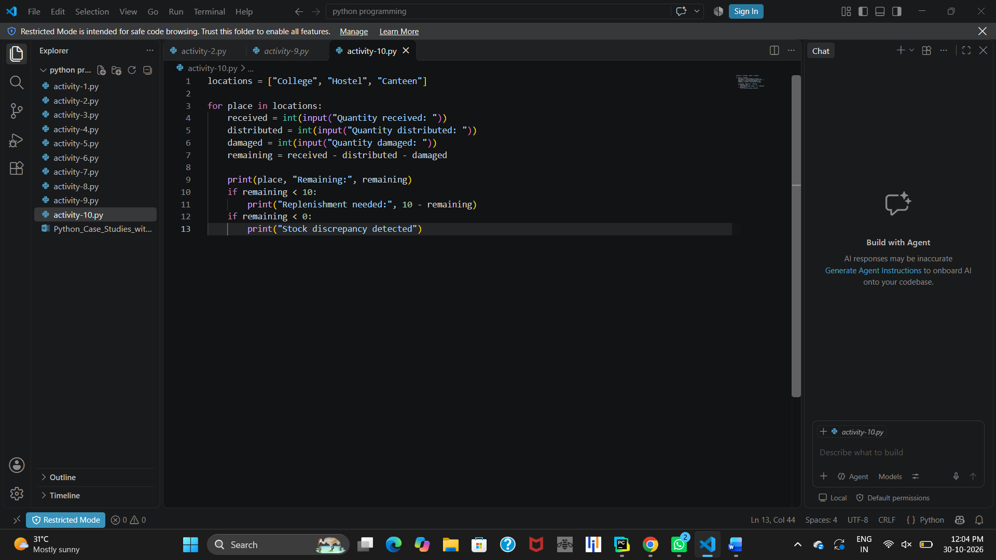Stock discrepancy detected

10. Conclusion
This Python program manages stock at different locations using lists and for loops. It calculates the remaining stock and identifies replenishment requirements and stock discrepancies using conditional statements. It helps in understanding lists, loops, arithmetic operations, and decision-making in Python.

